|  |
| --- |
| MediaScape Pharmacies  **Pharmacy System**, Made by:   1. Mohamed Hesham Mohamed 2. Mohamed Ahmed Mahmoud 3. Mohamed Shabaan Mohamed 4. Mohamed Mamdouh Sayed 5. Mohamed Mamdouh Abo-Elwafa   Under the Supervision of Dr, Hadeer.  Group number: 6  Submission date: 22/5/2024  Course Title: Advanced Programming |
|  |

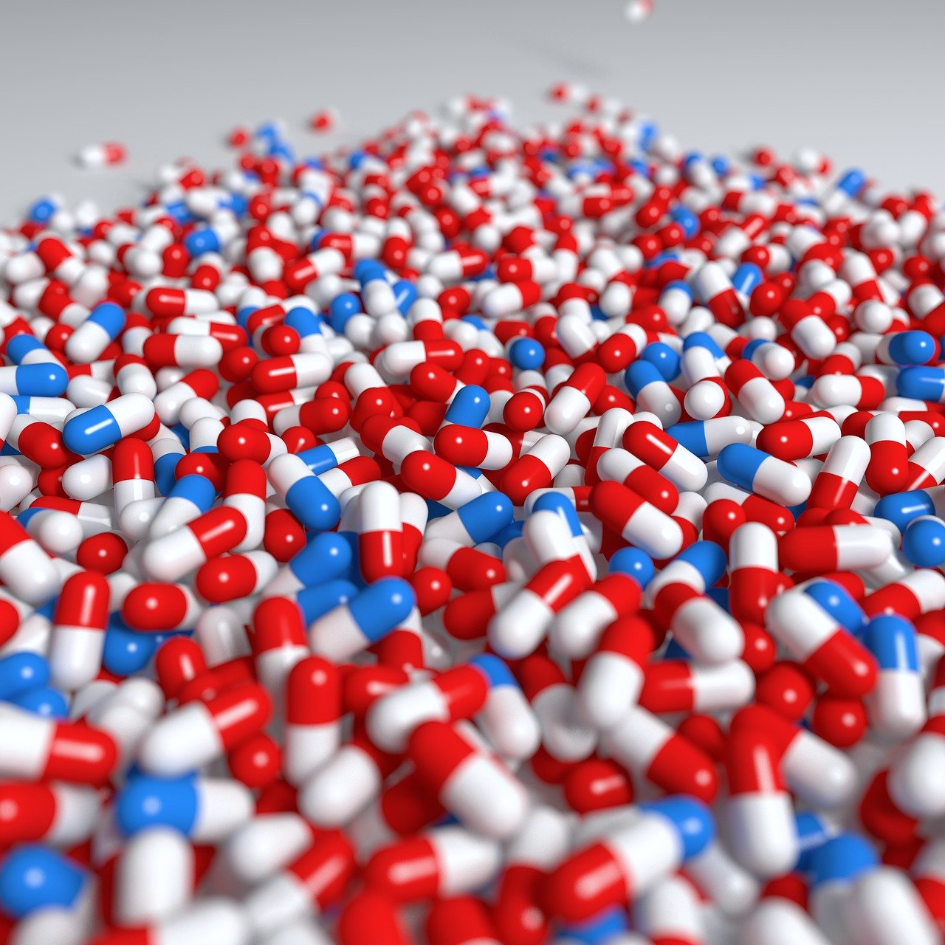

j

Introduction:

Amazon, noon, and these applications of online shopping have taken a great part of our shopping experience in the last few years, but online shopping isn’t always great and may have some restrictions on what you are buying. In this project we have taken online shopping to a new perspective keeping ourselves away from the bold restriction lines, and producing a product that could help save someone’s life, this project is about a Pharmacy online shopping system. This project includes making accounts through the system, choosing products from different branches of the pharmacy, and going through transactions if the quantity chosen is compatible with the quantity in the pharmacy.

Purpose and Method (A deeper dive):

Sometimes you may find It difficult to buy your important medicine in the pharmacy around you, therefore making an online pharmacy application with access through different branches could solve this problem easily. The method we have taken to facilitate this process is making an easy yet effective graphical user interface to make the user able to do his orders without complexity. Users can choose multiple medicines from 2 branches (which could be more in future work) and then do a cumulative transaction for both branches at the same time!!

The project is file-based. Users must have an account to be able to do transactions. The process of buying is so easy, the user should add to the cart the quantity he wants of whatever product and when he finishes, he then can buy all the things in the cart as if he is shopping in a supermarket! Signing in is smooth and easy for the user, it includes a username, password, Phone number, and other general information.

However, Verification is quite an important aspect of our project!

Safety comes first.

To make the program light for the eye, we used labels on panels as buttons to make it comfortable and satisfying for the eye to see and added some interactions between some labels and the user.

Snapshots from the Program:

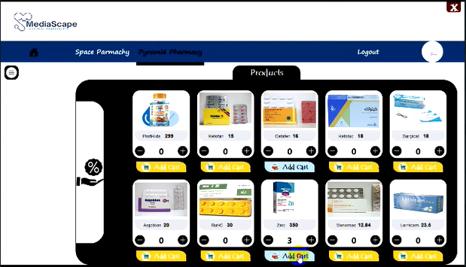

UML Diagrams:

Use Case Diagram:

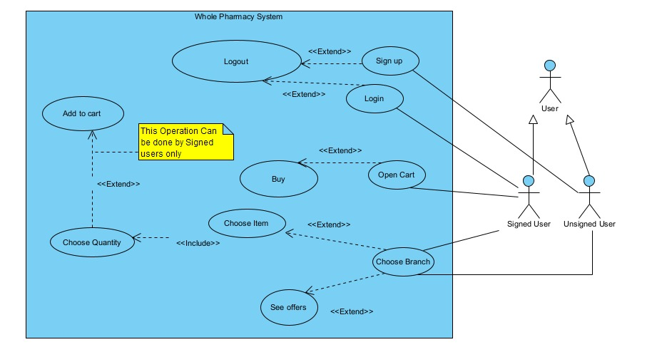

Class Diagram:

Sequence Diagram:

Teamwork and Management:

The tasks of the application have been distributed as follows:

Mohamed Shabaan Mohamed: GUI with advanced Interactions with the user and high-quality figures. (Some shapes in the GUI are even made with code)

Mohamed Mamdouh Sayed: GUI with advanced Interactions with the user + Class Diagram

Mohamed Mamdouh Abo-Elwafa: Login and Signup processes with Verification

Mohamed Hesham Mohamed: Space Pharmacy branch backend programming + Use Case diagram + Sequence Diagram.

Mohamed Ahmed Mahmoud: Pyramid Pharmacy branch backend programming